UNIVERSITY OF ABERDEEN SESSION 2017/18

Degree Examination

EG5099 Upstream Oil and Gas Processing

Dec 2017

**PLEASE NOTE THE FOLLOWING**

1. You **must not** have in your possession any material other than that expressly permitted in the rules appropriate to this examination. Where this is permitted, such material **must not** be amended, annotated or modified in any way.
2. You **must not** have in your possession any material that could be determined as giving you an advantage in the examination.

(iii)You **must not** attempt to communicate with any candidate during the exam, either orally or by passing written material, or by showing material to another candidate, nor must you attempt to view another candidate’s work.

**Failure to comply with the above will be regarded as cheating and may lead to disciplinary action as indicated in the Academic Quality Handbook (**[**www.abdn.ac.uk/registry/quality/appendix7x1.pdf**](http://www.abdn.ac.uk/registry/quality/appendix7x1.pdf)**) Section 4.14 and 5.**

# CANDIDATE INSTRUCTIONS

## Attempt all 5 questions

WITH ANSWERS

### Question 1

1. The following is a generic, multi-component hydrocarbon phase envelope. Describe the phase states in the isothermal transition from A to B. Pay particular attention to gas to liquid ratios.

[6 marks] 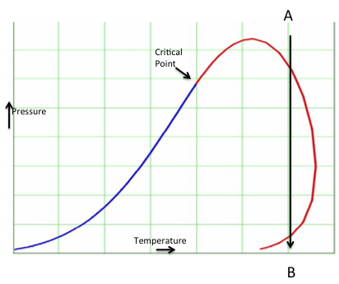

A is vapour. (1 mark)

As the pressure drops at constant temperature the dewpoint locus is met. Here liquid begins to condense. (1 mark)

As pressure continues to drop more liquid will condense increasing the L/V ratio. (1 mark)

The L/V ratio will reach a maximum after which further pressure reduction will result in the L/V ratio reducing. (2 marks)

The dew point locus will again be encountered with B being all vapour. (1 mark)

1. Stream 1 on the following figure is a two-phase hydrocarbon mixture at pressure P1 and T1, it is mixed with recycled condensate (8) also at pressure P1 and fed to a two-phase separator V100 at temperature T2, controlled at pressure P2. The gas evolved (4) is taken to a cooler (HX001) where it is cooled to T3. The pressure drop across the exchanger is ΔP. Stream 5 enters a two-phase separator V101 operating at the same pressure as HX-100 outlet. The gas stream (6) moves to another part of the process. The liquid from V101 (7) feeds the recycle pump P100, which increases the pressure of the liquid to P1. On a generic, mixed hydrocarbon phase envelope, indicate the temperature and pressure position of streams 1,4,5,7 and 8. Explain your reasoning for the positions identified. Assume that pipework friction and elevation effects are negligible.

[10 marks]

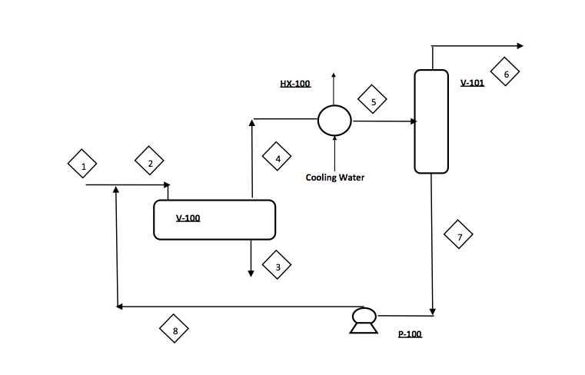

Answer 2 marks each

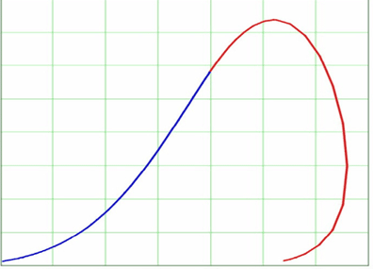

Pressure

Temperature

Critical Point

1 P1, T1

B

4 P2, T2

5 P2 – ΔP , T3

7 P2 – ΔP , T3

8 P1 , T3

1 is a two phase mixture hence inside the phase envelope

4 the gas will be on the dewpoint locus in equilibrium with the liquid at separator operating conditions

5 the cooler will result in condensation. Hence a two phase mixture at P2 – ΔP and T3

7 the liquid will be on the bubble point locus locus in equilibrium with the gas at separator V101 operating conditions

8. is a single phase liquid at P1 and T3

1. You have completed a heat and mass balance using the Peng-Robinson equation of state and find that one of the unit operations is operating in the two phase region close to the critical point. Comment on your confidence on the accuracy of the predicted properties produced by the simulator for that particular unit operation. [4 marks]

At the critical point all the quality lines converge. Hence very small changes in temperature and pressure will result in large changes to vapour/liquid ratio. No EOS is accurate around the CP hence confidence would be low.

### Question 2

1. A liquid phase mixture of propane, n-butane and n-pentane is pipeline transported. The pipeline route can be simplified into two segments each 3000 m long. The first segment rises to a height of 500 m, the second dropping 500 m back to the same level as the pipeline inlet. The pipeline entry temperature is 80 oC, the inlet pressure is 3000 kPa. The flowrate is 2500 kgmole/hr and the mole fractions of the components propane, n-butane and n-pentane are 0.4, 0.3 and 0.3 respectively. The density is 496 kg/m3. The internal diameter of the pipe is 250 mm. The pipeline is highly insulated, hence flow can be assumed to be isothermal. Pipeline production will be curtailed if vapour forms at the pipeline apex. Using the attached equilibrium K factors determine whether vapour will form at the apex. State any assumptions. Hint - some information provided may be superfluous.

[10 marks]

The student should realise that if elevation changes alone produce vapour at the apex then additional pressure loss due to friction will only make vapour evolution more likely. (4 marks)

Considering elevation alone the pressure at the apex will be 3000 – 496 x 9.81 x 500/1000 = 567 kPa (1 mark)

The conditions at the apex if the flow is isothermal is 80oC and 567 kPa. (1 mark)

Undertake a bubble point calculation at these conditions knowing the bub pt will occur when ∑Kx = 1. If it is higher than this then the fluid is two phase. (2 marks)

Using charts Kpropane = 5, Kbutane = 1.8, Kpentane = 0.7

Thus ∑Kx = 5 x 0.4 + 1.8 x 0.3 + 0.7 x 0.3 which is greater than 1 so vapour break out will occur. (2 marks)

1. A hydrocyclone is used to remove oil droplets from a continuous water phase. Describe the operating principles of a hydrocyclone.

[6 marks]

The hydrocyclone consists of four sections: a cylindrical swirl chamber, a concentric reducing section, a fine tapered section, and a cylindrical tail section. (2 marks)

The oily water enters the cylindrical swirl chamber through a tangential inlet, creating a high-velocity vortex with a reverse-flowing central core. The fluid accelerates as it flows through the concentric reducing section and the fine tapered section. The fluid then continues at a constant rate through the cylindrical tail section. Larger oil droplets are separated out from the fluid in the fine tapered section, while smaller droplets are removed in the tail section. (2 marks)

Centripetal forces cause the lighter-density droplets to move toward the low pressure central core, where axial reverse flow occurs. The oil is removed through a small-diameter reject port located in the head of the hydrocyclone separator. Clean water is removed through the downstream outlet. (2 marks)

1. Typical separation performance of a hydrocyclone is shown as follows. Explain what is happening at low and high vortex velocities which would cause separation efficiency to drop.

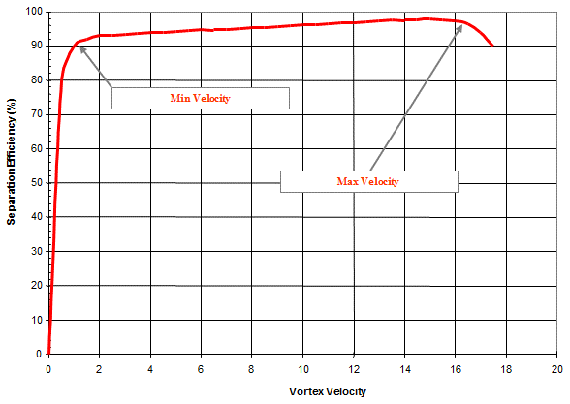

Hydrocyclone Separation Efficiency

[4 marks]

A certain minimum vortex flow rate is necessary to set up the vortex motion and to establish centrifugal separation forces that grow in intensity as the flow rate increases and improve the separation efficiency. (2 marks)

At very high vortex flow rates, shearing of the oil droplets can occur, creating smaller droplets that are harder to separate. (2 marks)

### Question 3

1. A three phase oil, gas, water gravity separator with no internals is producing an oil product which meets the required water specification without the use of demulsifiers. New wells are introduced to the separator from a different reservoir that has a higher oil viscosity and density. Furthermore the new wells have downhole electric submersible pumps. It is found that the introduction of these new wells causes the water in oil content to increase and exceed specification. Identify four reasons why the water in oil content increases.

[4 marks]

Droplet settling velocity is given by;



The increase viscosity will hinder separation.

The reduced density difference will hinder separation.

The downhole pump will introduce shear causing smaller droplets.

The additional flow from the new wells will lower the separator residence time.

1 mark each.

1. You are requested to investigate means for improving the water in oil content. What would you suggested be investigated?

[6 marks]

Note the answers build upon 3a)

Increase operating temperature to reduce viscosity.

Review vessel geometry to determine whether droplet growth devices such as tilted plates could be retrofitted.

Review the benefits of an inlet device to provide some pre-separation.

Review if operating levels can be increased to provide additional residence time.

Conduct bottle tests to establish the benefits from demulsifier addition.

Consider use of a diluent of lower density and viscosity.

1 mark each

1. As part of a carbon capture scheme, a CO2 compression system is required to deliver CO2 at 100 bara and 30 0C. The CO2 is captured from a gas turbine flue gas using amine absorption. The CO2 is delivered from the amine regenerator to the first compressor at 1 bar and 40 0C. The gas turbine uses methane as fuel and has a combustion efficiency of 48%. The output from the turbine is 400 megawatts. Using the attached CO2 Mollier chart estimate the number of compression stages and power required by the CO2 compression system. As a first approximation assume the calorific value of methane is 40,000 kJ/kg, the compressors operate isentropically and that the maximum compressor outlet temperature from each stage of compression is 150 0C. Cooling water is available at 20 0C. State any other assumptions. Enclose your Mollier chart including you student number with the returned exam paper.

[10 marks]

The inlet to the first compressor will be A (1 mark)

Follow the isentropic path to B at 150 0C (1 mark)

Enthalpy change 840 – 740 = 100 kJ/kg (1 mark)

Assume a 5 0C temperature approach and cool to 25 0C – point C (1 mark)

Repeat C to D 835 – 735 = 100 kJ/kg

F to E 780 – 710 = 80 kJ/kg

Hence total compression power = 280 kJ/kg (1 mark)

Require flow of CO2 in kg/s

Amount of methane fuel = 400 x 106 / (40000 x 1000 x 0.48) = 20.8 kg/s = 1.3 kgmol/s (1 marks

Assuming stoichiometric combustion that will produce 1.3 kgmol/s CO2 = 57.2 kg/s CO2 (2 marks)

Total power 280 x 57.2 = 16000 kJ/s = 16 MW (1 mark)

3 stages of compression required (1 mark)

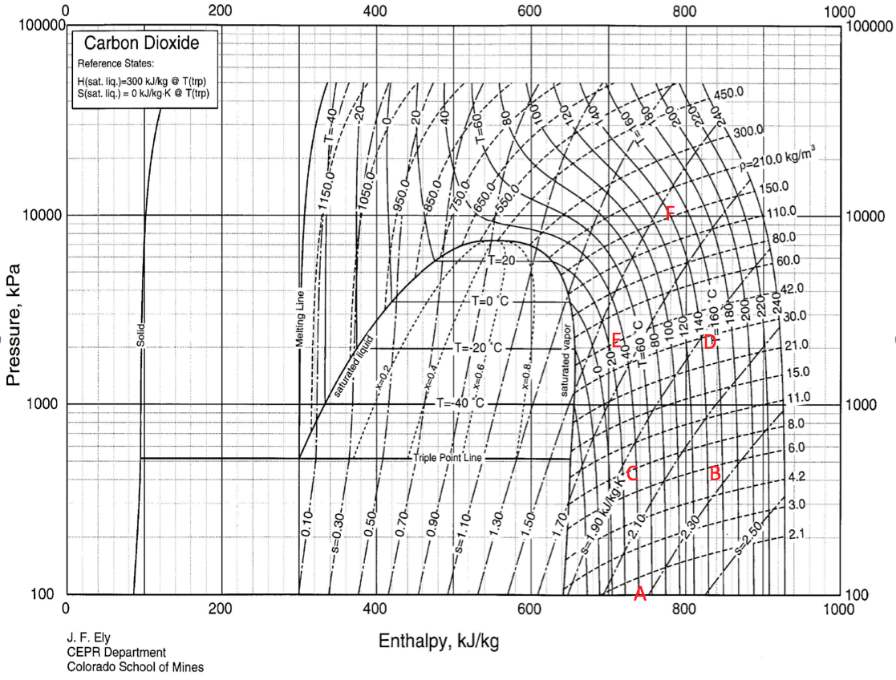

### Question 4

1. A process gas is to be cooled from 20 oC to minus 35 oC using a refrigeration plant. The refrigerant is propane. Using the attached Mollier chart for propane estimate the compressor energy savings between a one and a two stage refrigeration system. Assume air is available at 25 oC for condensation. State any other assumptions.

Enclose your Mollier chart including you student number with the returned exam paper.

[14 marks]

Assume a 5 oC temperature approach for condensation and evapouration. That means that the propane will have to be compressed to a pressure that corresponds to 25 + 5 = 30 oC. From the Mollier chart that is around 1200 kPa. To cool the process to -35 oC requires an evaporator pressure of 120 kPa ( -40 oC) . The Mollier chart can now be used to complete the one stage refrigeration system. (4 Marks)

A to B compression – isentropic enthalpy change = 925 – 825 = 100 kJ/kg (1 mark)

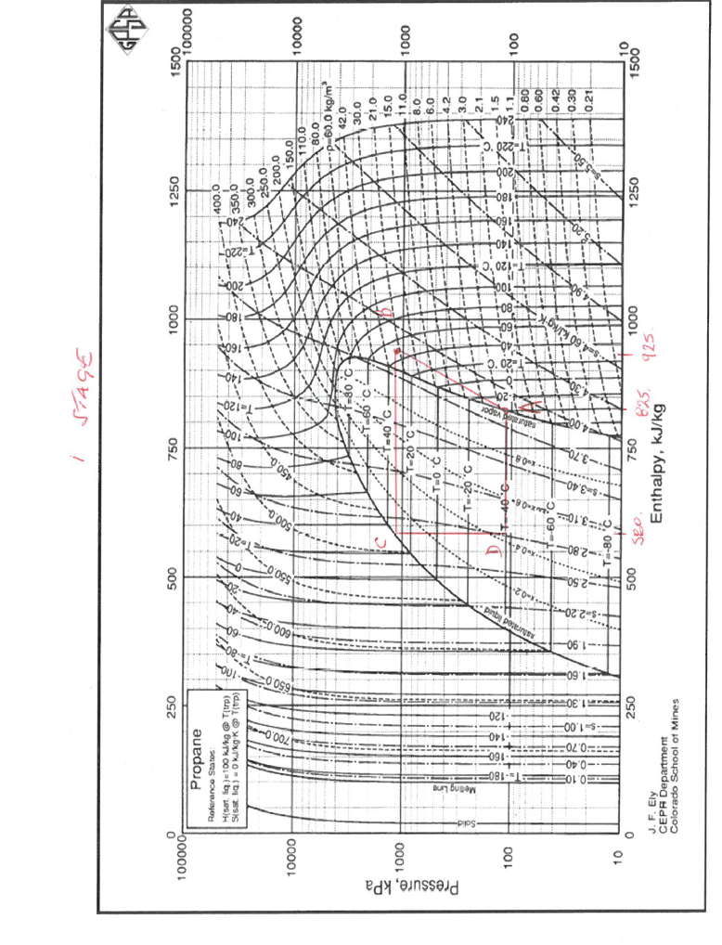D to A evapouration duty = 825 – 580 = 245 kJ/kg (1 mark)

Hence for 1 kJ/s of heat removed the propane circulation rate will be 1/245 = 0.0041 kg/s

Hence compressor power = 0.0041 x 100 = 0.41 kJ/s (1 mark)

Compare to 2 stage refrigeration

Assume first stage cools process from 20 to -7.5 oC .

To cool the process to -7.5 oC requires evaporator pressure of 350 kPa ( -12.5 oC). The Mollier chart can now be used to complete the first stage of the two stage refrigeration system. (2 marks)

A to B compression – isentropic enthalpy change = 925 – 850 = 75 kJ/kg (1 mark)

D to A evapouration duty = 850 – 590 = 260 kJ/kg (1 mark)

Assume each stage of the two stage process removes half the heat of the one stage system 0.5 kJ/s of heat removed (1 mark)

then the propane circulation rate will be 0.5/260 = 0.0019 kg/s

Hence compressor power = 0.0019 x 75 = 0.085 kJ/s

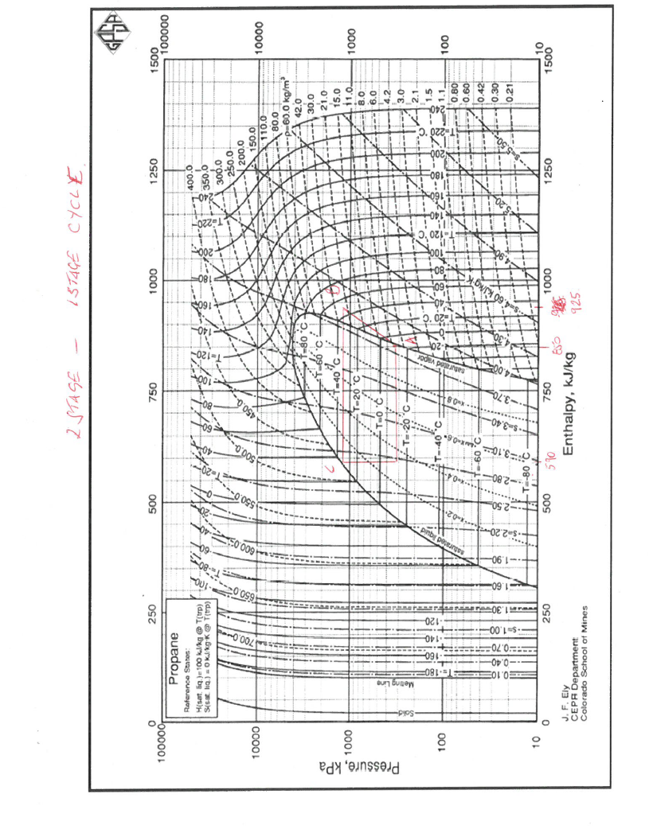The second refrigeration stage will be as the one stage process but the heat removed will be 0.5 kJ/s so the compressor power will be 0.5 x 0.41 = 0.205 kJ/s

Total power for two stages = 0.205 + 0.085 = 0.29 kJ/s (2 mark)

So 2 stages is 0.29/0.41 x 100 = 70% of 1 stage power. (1 mark)

1. What factors would you investigate to provide justification for a one or two stage refrigeration system? Explain their significance.

[6 marks]

Capital cost – two stages more costly - key for economic decision.

Operating cost – two stage uses less energy - key for economic decision.

Availability - two stage is more likely to suffer breakdowns as there is more equipment.

Revenue - key for economic decision.

Safety – two stage has double the amount of leak paths.

Environment – two stage has improved carbon footprint.

(1 mark each)

### Question 5

1. Sketch and describe four common multi-phase flow patterns that might occur in a horizontal pipeline transporting a mixture of gas and oil.

[4 marks]

Answer – (1 mark each for any 4 of the following)

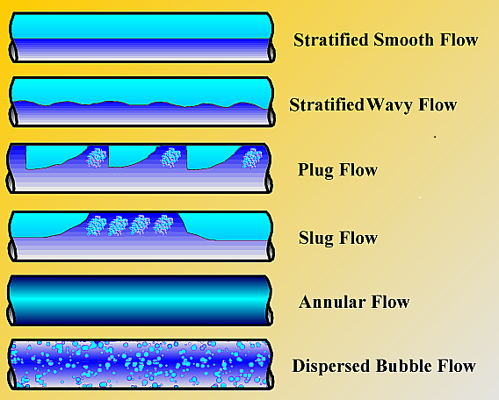

**Dispersed Bubble Flow**

* Small bubbles of gas flowing at same velocity as liquid

**Plug/Bubble Flow**

* Pipe is almost completely filled with liquid and the free gas phase is present in

small bubbles.

* Pipe wall is always contacted by the liquid phase

**Slug/Intermittent Flow**

* Liquid phase with accompanying gas bubble gas

**Stratified Flow**

* Pipe acts as a separator
* Liquid flows along bottom with gas above

**Annular Flow**

* High velocity gas core
* Liquid annulus surrounds gas core

1. Gas and liquid are flowing in a vertical pipe of diameter D1. Pressure drop readings are taken across the pipe and recorded as ΔP1. The pipe diameter is increased to D2, the gas and liquid rate remains the same and the pressure drop reduces from ΔP1 to ΔP2. A further increase in pipe diameterto D3 is made. The gas and liquid rate remains the same but this time the pressure drop increases from ΔP2 to ΔP3. Explain the reason for the observed pressure drop trend?

[8 marks]

Pressure drop will be made up of friction and elevation losses. Acceleration term can be assumed to negligible (2 marks)

At the smallest diameter phase velocities will be at their largest and the friction term will dominate. Increasing the pipe diameter to D2 reduces velocity hence friction losses are reduced and a lower pressure drop is observed. (2 marks)

For the largest diameter phase velocity is reduced to an extent that significant phase slippage occurs. The more mobile gas flows faster than the liquid resulting in a higher liquid to gas ratio with a consequent higher two phase density. (2 marks)

Although friction losses will have reduced elevation losses (ρ.g.h) now dominate and the pressure drop increases. (2marks)

1. A downward sloping, 1200m long pipeline with an internal diameter of 0.292m joins a 100m long vertical pipe (riser) of the same diameter. The pipeline contains oil, gas and water flowing at an average pressure of 25 bara. The flow rates are:

Oil = 0.005 m3/s

Water = 0.005 m3/s

Gas = 0.041 m3/s

The oil and water densities are 850 and 1000 kg/m3 respectively.

Determine if the system of pipeline and riser will be prone to severe slugging at the given flowing conditions. Hint: calculate the maximum rate of pressure rise in the vertical riser and compare that with the rate of pressure rise of the gas portion of the pipeline. State your assumptions.

[8 marks]

Cross section of pipe and riser = 3.14 x 0.2922/4 = 0.067 m2

For severe slugging to occur the liquid bridges the bend at the riser and prevents gas entering the riser. Hence, only liquid fills the riser.

Combined oil and water density = (850+1000)/2 = 925 kg/m3 - assume no slippage between phases.

Volume flow of oil and water = 0.005 + 0.005 = 0.01 m3/s

Velocity of oil and water = 0.01/0.067 = 0.15 m/s

The rate of pressure rise as the riser is filling up at 0.15 m/s is;

= density.g.H = 925 x 9.81 x 0.15

= 1361 kg/m.s2/s = pascal/s

= 0.0136 bar/s pressure rise in the riser. (2 marks)

Assume no phase slippage in the pipeline, the fraction of gas in the pipeline is equal to the volume of gas/ (volume of gas + volume of liquid);

= 0.041/(0.041+0.005+0.005)

= 0.80

Therefore, the volume of gas in the pipeline

= pipe CSA x pipeline length x the fraction of gas

= 0.067 x 1200 x 0.8

= 64.3 m3 (2 marks)

Assuming the ideal gas law holds then the rate of pressure rise in the pipeline gas bubble will be proportional to the rate of mass increase of the gas fraction of the pipeline.

Hence rate of pressure rise of gas fraction in pipeline will be;

gas volume rate/volume of gas in pipeline x system pressure

= 0.041/64.3 x 25

= 0.016 bar/s (2marks)

Rate of pressure rise in riser (0.0136 bar/s) is lower than rate of pressure rise in pipeline (0.016 bar/s) hence the system will not be prone to severe slugging. (2 Marks)

## END OF PAPER

## **Figures and charts**

**Question 2 a – K Equilibrium Ratios**







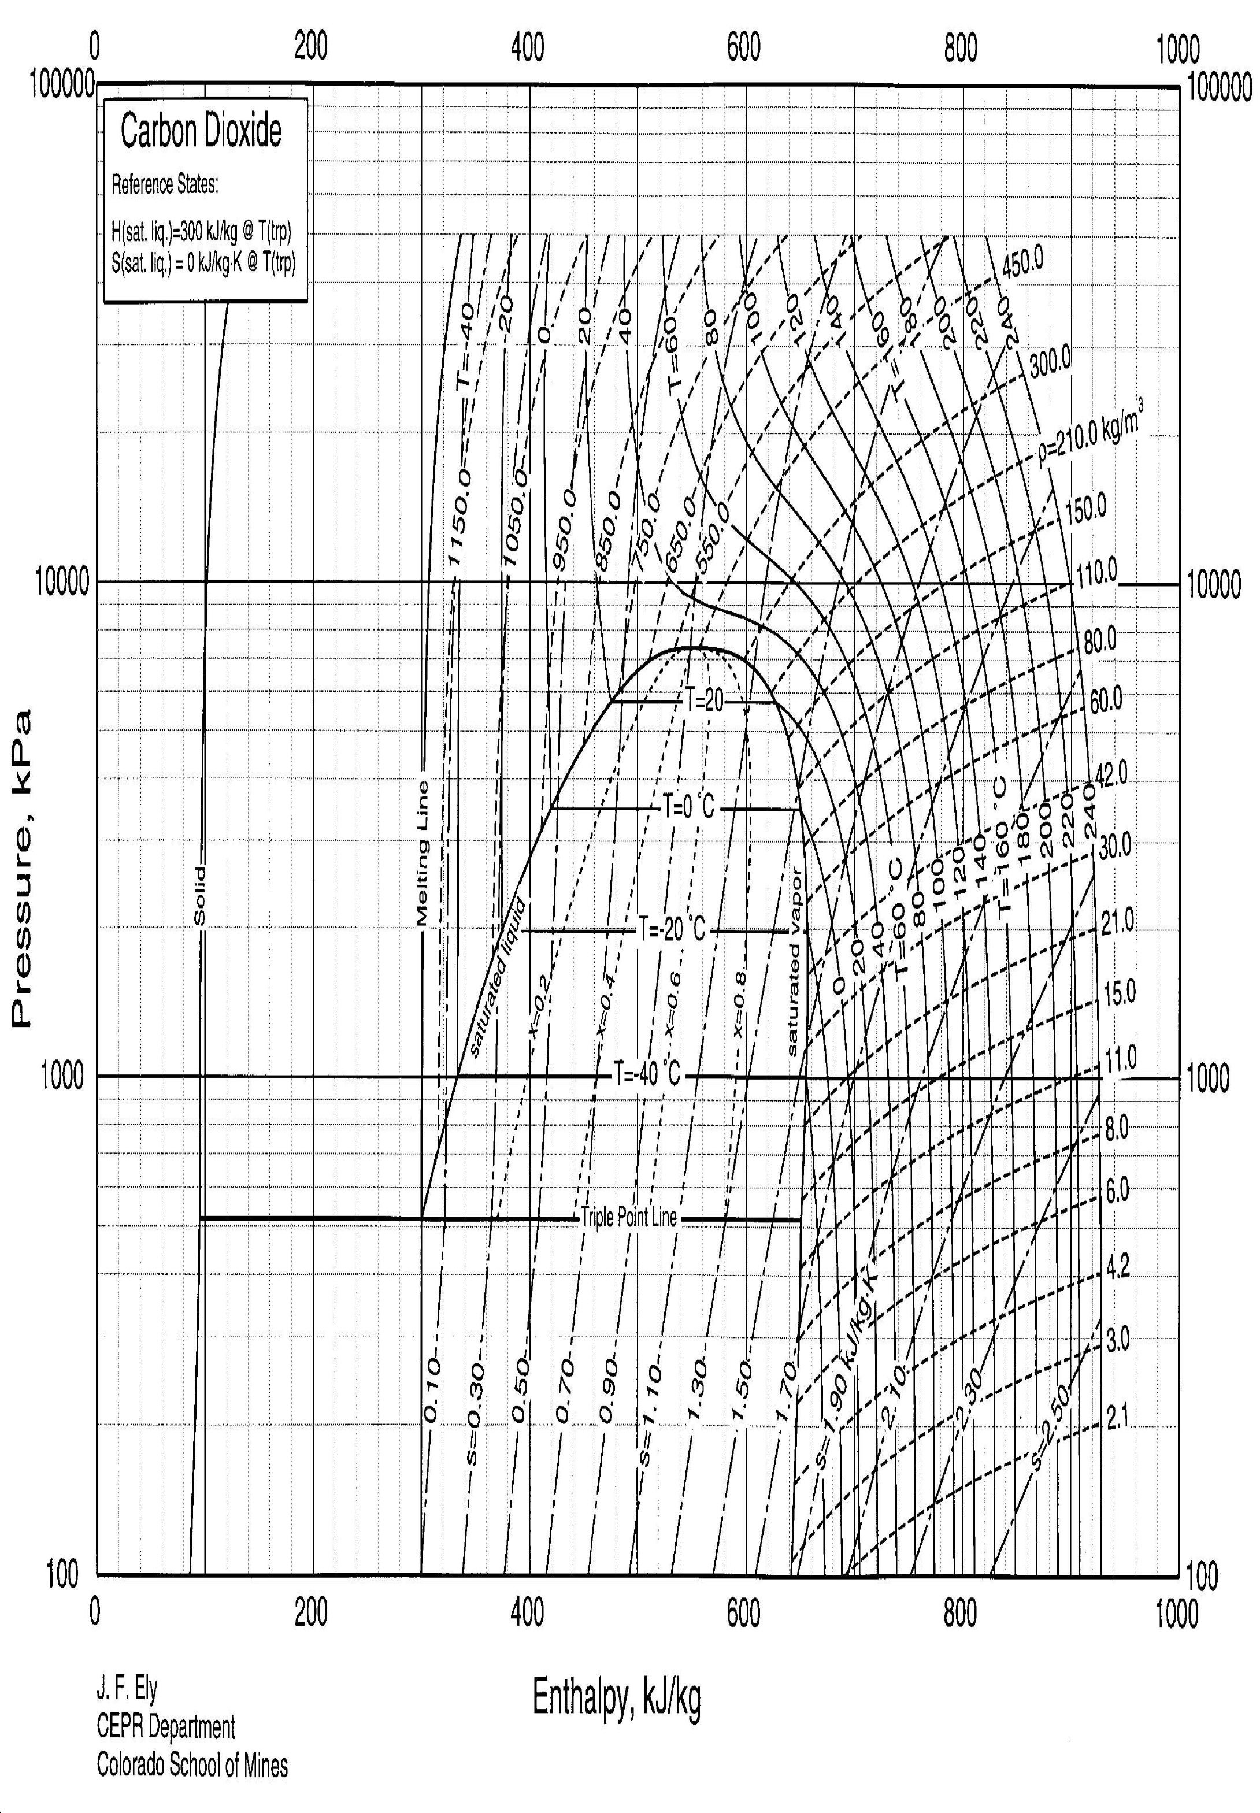**Question 3c – CO2 Mollier Chart**

**Question 4a – Propane Mollier chart**

